**Assignment 05**

**Problem 1:**

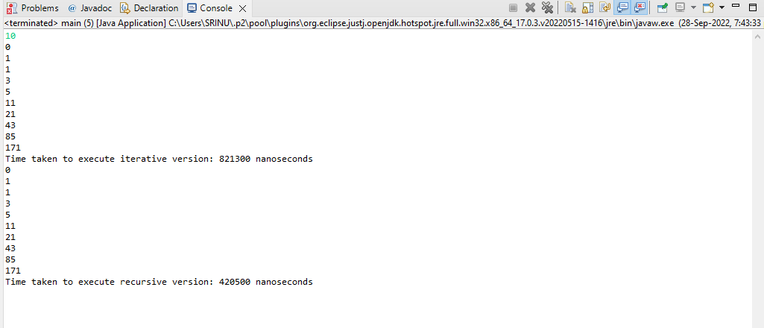

**Problem 2:**

